Worship December, 2007 Lectionary Year A

Date | Service | Scriptures | Sermon or Event
Dec. 2 | 1st Sunday in Advent  Holy Communion  Paraments are purple | Romans 13:11-14  Matthew 24:36-44 | The Way of Salvation
Dec. 9 | 2nd Sunday in Advent  purple | Matthew 3:1-11 | Staci Comer’s mission trip
Dec. 16 | 3rd Sunday in Advent  purple | Matthew 11:2-11 | Choir Christmas program
Dec. 23 | 4th Sunday in Advent  purple | Matthew 1:18-25 | How Far Is It from Nazareth to Bethlehem?
Dec. 24  7:30 pm | Christmas Eve Candlelight  Holy Communion  Paraments are white | Luke 2:1-20 | Recapture the Wonder
Dec. 30 | 1st Sunday after Christmas  white | A Festival of Nine Lessons and Carols  Genesis 3:8-15, 17-19; 22:15-18; Isaiah 9:2, 6-7; Micah 5:2-5a; Luke 1:26-35, 38; 2:1-7; 8-16; Matthew 2:1-11; John 1;1-14

Music
Hymn of the Month Star Child
Date Dec. 2 Listen ↓
196 Come, Thou Long-Expected Jesus Hyfrydol http://www.cyberhymnal.org/htm/c/o/m/comtlong.htm
2095 Star Child Star Child
206 I Want to Walk as a Child of the Light Houston
Date Dec. 9
211 O Come, O Come Emmanuel Veni Emmanuel http://www.hymnsite.com/lyrics/umh211.sht
2095 Star Child Star Child
Date Dec. 16
2095 Star Child Star Child
Date Dec. 23
230 O Little Town of Bethlehem St. Louis http://www.cyberhymnal.org/htm/o/l/olittle.htm
2095 Star Child Star Child
240 Hark! The Herald Angels Sing Mendelssohn http://www.cyberhymnal.org/htm/h/h/a/hhangels.htm
Date Dec. 24
234 O Come, All Ye Faithful Adeste Fideles http://www.carols.org.uk/o_come_all_ye_faithfu1.htm
2095 Star Child Star Child
239 Silent Night Stille Nacht http://www.cyberhymnal.org/htm/s/i/silntnit.htm
246 Joy to the World Antioch http://www.cyberhymnal.org/htm/j/o/joyworld.htm

Date Dec. 30
234 O Come, All Ye Faithful Adeste Fideles http://www.carols.org.uk/o_come_all_ye_faithfu1.htm
2095 Star Child Star Child
251 Go, Tell It on the Mountain Go, Tell It http://www.cyberhymnal.org/htm/g/o/gotitotm.htm
2095 Star Child Star Child
230 O Little Town of Bethlehem St. Louis http://www.cyberhymnal.org/htm/o/l/olittle.htm
238 Angels We Have Heard on High Gloria http://www.youtube.com/watch?v=T42ieABEY-A
219 What Child Is This Greensleeves http://www.cyberhymnal.org/htm/w/h/whatcist.htm
228 He Is Born Il Est Ne http://www.cyberhymnal.org/htm/h/e/heisborn.htm
254 We Three Kings Kings of Orient http://www.cyberhymnal.org/htm/w/e/wethree.htm
240 Hark! the Herald Angels Sing Mendelssohn http://www.cyberhymnal.org/htm/h/h/a/hhangels.htm
245 The First Noel The First Noel http://www.youtube.com/watch?v=2awgnmCvbhM&feature=related

GBOD has given us a worship calendar for 2008
http://www.gbod.org/worship/2008cwrplanningcal.pdf

Check it out!

< Previous
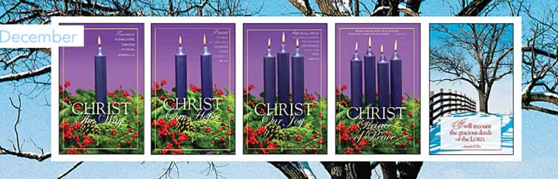

Sunday | 2 | 9 | 16 | 23 | 30
Liturgical Day | First Sunday of Advent | Second Sunday of Advent | Third Sunday of Advent | Fourth Sunday of Advent | First Sunday After Christmas
Special Day
Lections Day | Isa. 2:1-5  Ps. 122 or UMH 845  Rom. 13:11-14  Matt. 24:36-44 | Isa. 11:1-10  Ps. 72:1-7, 18-19 or UMH 795  Rom. 15:4-13  Matt. 3:1-12 | Isa. 35:1-10  Luke 1:47-55 or UMH 199  Jas. 5:7-10  Matt. 11:2-11 | Isa. 7:10-16  Ps. 80:1-7, 17-19 or UMH 801  Rom. 1:1-7  Matt. 1:18-25 | Isa. 63:7-9  Ps. 148 or UMH 861  Heb. 2:10-18  Matt. 2:13-23
Suggested Colors | Purple or Blue | Purple or Blue | Purple or Blue | Purple or Blue | White

Sunday | Monday | Tuesday | Wednesday | Thursday | Friday |  | Saturday
 |  |  |  |  |  |  | 1
2  First Sunday in Advent | 3 | 4  Hanukkah | 5 | 6 | 7 |  | 8
9  Second Sunday in Advent | 10 | 11 | 12 | 13 | 14 |  | 15
16  Third Sunday in Advent | 17 | 18 | 19 | 20 | 21 |  | 22  Winter Solstice  First Day of Winter
23  Fourth Sunday in Advent | 24  Christmas Eve  Nochebuena | 25  Christmas Day | 26  Kwanzaa (26-Jan. 1)  Boxing Day (Canada) | 27 | 28 |  | 29
30 | 31  New Year's Eve  Watch Night
< Previous

